Formatting Template and Instructions for MATC Final Reports

Please use the following template when formatting final reports for all MATC research reports. The purpose of the template is to foster uniformity in MATC reports to ensure that information is easily accessible to all individuals. All reports must be submitted in Word format to enable the editors to format and proofread the report.
Please delete this page before submitting the report.
This Is the Title of My MATC Research
Final Report about Pavement

Name of PI, degrees
Title of PI
Department
Affiliation of PI

Name of Co-PI, degrees
Title of Co-PI
Department
Affiliation of PI

Name of researcher/co-author, degrees
Title of research/co-author
Department
Affiliation of researcher/co-author
Name of Researcher/co-author, degrees
Title of research/co-author
Department
Affiliation of researcher/co-author

Name of researcher/co-author, degrees
Title of research/co-author
Department
Affiliation of researcher/co-author

Name of researcher/co-author, degrees
Title of research/co-author
Department
Affiliation of researcher/co-author

A Report on Research Sponsored by

Mid-America Transportation Center
University of Nebraska–Lincoln

March 2019 (month and year report was received/published by NTC/MATC)

Technical Report Documentation Page
1. Report No.  The WBS # appears (xx-xxxx-xxxx-xxx) | 2. Government Accession No. |  |  | 3. Recipient's Catalog No.
4. Title and Subtitle  The full title should appear here exactly as it is on the title page. |  |  |  | 5. Report Date  The date the report was received/published should appear here and on the title page, like March 2017
 |  |  |  | 6. Performing Organization Code
7. Author(s)  This is where the authors’ and researchers’ full names appear followed by their ORCID URL. |  |  |  | 8. Performing Organization Report No.  This is also where the WBS # appears
9. Performing Organization Name and Address  Mid-America Transportation Center  Prem S. Paul Research Center at Whittier School  2200 Vine St.  Lincoln, NE 68583-0851 |  |  |  | 10. Work Unit No. (TRAIS)
 |  |  |  | 11. Contract or Grant No.
12. Sponsoring Agency Name and Address  Office of the Assistant Secretary for Research and Technology  1200 New Jersey Ave., SE  Washington, D.C. 20590 |  |  |  | 13. Type of Report and Period Covered  This is where the dates of the research appear, like June 2011-December 2011
14. Sponsoring Agency Code
MATC TRB RiP No. 34760
15. Supplementary Notes

16. Abstract
This is where the abstract will appear as a single paragraph.
17. Key Words  Add keys words here. |  |  | 18. Distribution Statement
19. Security Classif. (of this report)  Unclassified |  | 20. Security Classif. (of this page)  Unclassified |  |  | 21. No. of Pages  # of numbered pages should appear here | 22. Price
Table of Contents
Acknowledgments (optional) viii
Disclaimer ix
Abstract x
Executive Summary (optional) xi
Chapter 1 Creating Chapter and Section Headings 1
1.1 Creating a new List Style 2
1.1.1 Link Level to Style 2
1.1.2 Subheadings 3
1.1.3 Formatting 3
1.2 Formatting Headings 4
1.2.1 Second Subheading Should be Italicized 4
1.2.1.1 Third Subheading Is Not Formatted 5
Chapter 2 Formatting Tables and Figures 6
2.1 Formatting a Table 6
2.2 Formatting a Figure 7
Chapter 3 Accessibility in Word 9
3.1 Alternative Text Guidelines for Images 9
3.1.1 Alternative Text Guidelines 9
3.1.2 Figure Example with Alternative Text 10
3.2 Table Headers 11
References 15
Appendix A Extra Information 16
A.1 First Subheading in Appendices 16
A.1.1 Second Subheading in Appendices 16
A.1.1.1 Third Subheading in Appendices 16
A.2 Tables and Figures in Appendices 16
A.3 Creating List of Tables and List of Figures 18

List of Figures
Figure 1.1 List styles location 1
Figure 1.2 New list style 2
Figure 2.1 Inserting a figure or table caption 6
Figure 2.2 The caption is placed below the figure 8
Figure 3.1 This is another example 10
Figure A.1 Creating appendix table and figure labels 16
Figure A.2 Here is another figure in the appendix 17
Figure A.3 Examples of a pumpkin (a), palm tree (b), kid (c), and rollercoaster (d) 17
Figure A.4 Creating a table of figures 19

List of Tables

Table 2.1 The title goes above the table 7
Table 3.1 Header row example 11

List of Abbreviations (optional)
Mid-America Transportation Center (MATC)
Nebraska Transportation Center (NTC)

Acknowledgments (optional)
This text is left aligned with a standard indent and double spacing. You might use this space to thank researchers or folks who helped with the project in some capacity.

Disclaimer
The contents of this report reflect the views of the authors, who are responsible for the facts and the accuracy of the information presented herein. This document is disseminated in the interest of information exchange. The report is funded, partially or entirely, by a grant from the U.S. Department of Transportation’s University Transportation Centers Program. However, the U.S. Government assumes no liability for the contents or use thereof.

Abstract
This text is left aligned with a standard indent and double spacing. I’m describing what I did in my project, and this text will also appear on the Technical Report Documentation Page.

Executive Summary (optional)
This text is left aligned with a standard indent and double spacing. You may have an Executive Summary in addition to an Abstract, although it is not necessary to have both. One or the other will suffice. If only an Executive Summary appears, it will be the text used as the abstract text on the Technical Report Documentation Page.

Creating Chapter and Section Headings
Using Word’s Styles makes it easy to create headings and automatically update numbers when things move around. This template has already created a List Style in the correct format, found in figure 1.1.

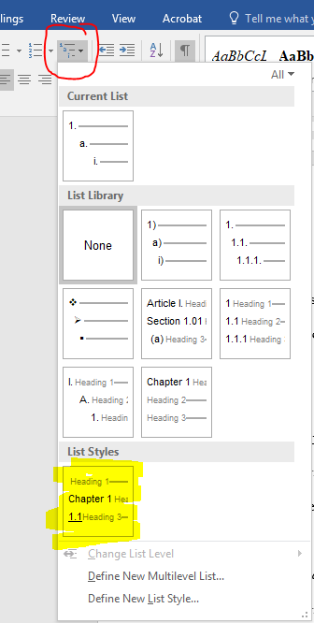
Figure 1.1 List styles location

If the highlighted list does not appear, or you have created a new document for your report, you can create a new list style to fit MATC report formatting.

Creating a New List Style
Select Define New List Style from the figure 1.1 menu and a popup window will appear. Select Format in the bottom left corner to give a dropdown menu, and select Numbering. Click More >> in the bottom left corner and format each level in the popup to look as follows.

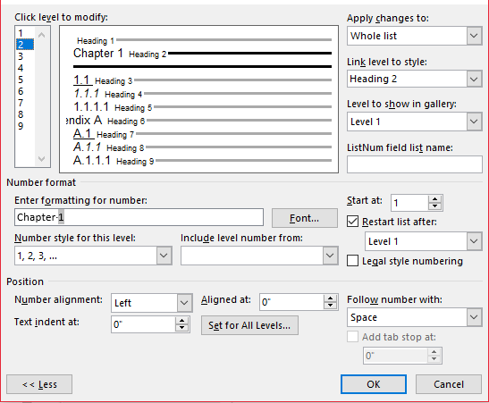
Figure 1.2 New list style

Link Level to Style
Notice that Chapter headings are linked to Heading 2, and a blank heading is linked to Heading 1. Heading 1 is used for Acknowledgements, Disclaimer, Abstract, and Executive Summary so it is easy for them to appear in the Table of Contents. Subheadings one to three are connected to Heading 3, 4, and 5. The Appendix and its subheadings are linked to Heading 6 – 9.

Subheadings
Some subheadings require calling upon the number from previous headings (see fig. 1.2). When creating those headings:
1. Delete anything in the ‘Enter formatting for number’ box
2. Select [Include level number from:] and select level 2 (or level 6 for appendices). The number 1 (letter A) will appear in the “Enter formatting for number” box. Type a period after the number and continue adding the previous levels followed by periods (i.e. 1.1, 1.1.1, and 1.1.1.1)
3. After the immediate preceding level, select Number style for this level: and select
[1, 2, 3, …].

Formatting
For the first and second subheadings, the numbers must be underlined or italicized. This can be done by selecting Font and the correct formatting from the popup window. You can then set the position with 0” indents and “Follow the Number With:” and select Nothing. After modifying each level, select Okay.
To apply the new list style, click somewhere on the line of your heading title. Select the List Styles button again, and click on your List Style. You can select Change List Level at the bottom to get the heading in the right place.
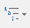
NOTE: you can come back to the list style formatting if something is wrong by clicking on the Multilevel List dropdown: , right clicking your list under “List Styles”, and selecting Modify.

Formatting Headings
The first subheading (linked to Heading 3) should be underlined, but when applying the style it may not look how you want. To open the style pane use Ctrl+Shift+S. Select Heading 3 and click Modify. Modify each heading to follow this template.
Use standard indent of 0. 5” and write in “normal” style for text in paragraphs. Everything should be double spaced with “0pt” for “Before” and “After” under Paragraph settings.

Second Subheading Should be Italicized
Use standard indent of 0.5” and write in “normal” style for text in paragraphs. Each chapter is formatted in this same way, please see the next chapter for instructions on formatting figures and tables. New chapters should always begin at the top of a new page.
Equations are numbered according to chapter. Each equation should be formatted as

X²=100 (1.1)
where X= the probability of something.

Include punctuation at the end of the equation because it completes the previous sentence. It is not necessary to compile equations in a list at the beginning of the report. They are numbered so that you can reference them easily in text. For example, refer to equation 1.1 and notice that there should be a blank line before and after the equation. The next equation in this chapter would be 1.2, and the next equation after that would be numbered 1.3, and so on.
If something being described needs to be cited, this can be done parenthetically at the end of the sentence using the author’s last name and the publishing year or the number of the reference, if using a numbered reference system (AASHTO 1997). The previous sentence uses an “author-date” citation, and this sentence features a numbered reference (1). Use one system or the other: not both.

Third Subheading Is Not Formatted
Here is an example of the third level subheading, which should not have any extra formatting.
This is a fourth level subheading. For subheading levels beyond the third level, use a “run-in” heading, which appears as an indented, italicized phrase at the beginning of the paragraph, with sentence style capitalization and a period following it. All subsequent subheadings can be formatted like this one. Other options for division could include numbered lists, although excessive listing is not recommended. These levels will not be included in the table of contents to encourage clarity and concision when viewing the overall organization of the document.

Formatting Tables and Figures
Tables and figures are numbered following the Chicago Manual of Style, and the labeling consists of two numbers separated by a decimal point with a text title following.
To insert a table or figure caption in relation to your headings select the References tab and Insert Caption (fig. 2.1).

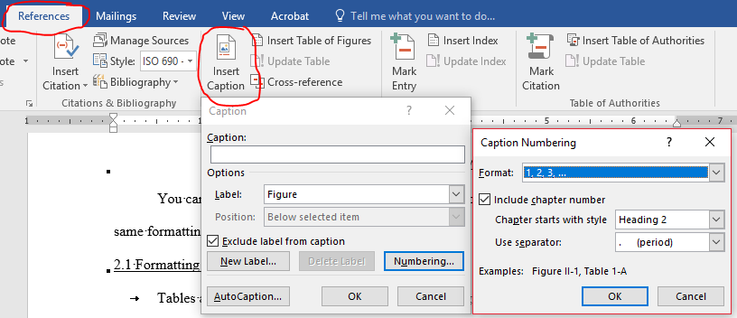
Figure 2.1 Inserting a figure or table caption

In the popup, select the Label: dropdown and Figure or Table, and checkmark Exclude label from caption. Select Numbering, checkmark Include chapter number, and Heading 2 (remember that we linked the chapter title to Heading 2), and use a period separator before selecting OK in both popups.

Formatting a Table
The first number of a table is the same as the chapter number and the second number is sequential for tables or figures, depending on which it is.

Table 2.1 The title goes above the table
Animal | Color | Age (in years)
Dog | Brown | 3
Cat | Black | 4
Fish | Orange | 1

Thus, since this is the first table of Chapter 2, it is table 2.1. Notice that in-text references to figures and tables are lowercase. If they happen to appear in parentheses, abbreviate figure (see fig. 2.1). Notice that on the table, the label and table number appears above. The whole label is centered and uses sentence-style capitalization. Notice that there is one whole blank line before and after the table. The same spacing should be applied to figures.
The next table in this chapter would be 2.2 and the following would be 2.3 and so forth. The tables are numbered the same way, but tables and figures are numbered independently of one another. In other words, if I include a figure and then include a table, the figure would be 2.1 and the table would also be 2.1.

Formatting a Figure
Formatting a figure is essentially the same as formatting a table, but the title goes below the figure (see fig. 2.1).

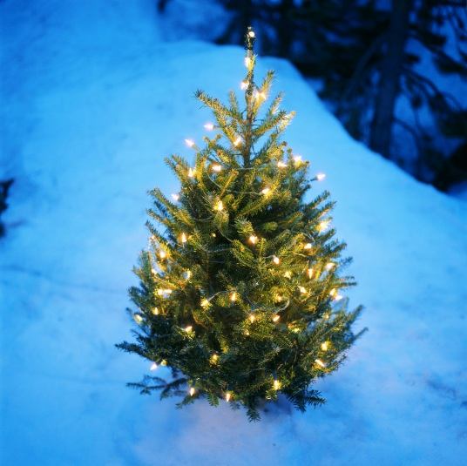
Figure 2.2 The caption is placed below the figure

Notice that the title and numbering for figures is below the figure but, similar to the table, it is centered with only the word “figure” and the figure number are bolded.
As with the table, please leave a full space before and after the figure, then continue the text. Look at the List of Figures in the beginning of the document. Note that the list is single spaced.

Accessibility in Word

Alternative Text Guidelines for Images

Alternative Text Guidelines
Alternative text is text associated with an image that serves the same purpose and conveys the same essential information as the image. In situations where the image is not available to the reader (perhaps because they have turned off images in their web browser or are using a screen reader due to visual impairment), the alternative text ensures no information or functionality is lost.
The following guidelines should be used when writing alt text:
- Alt text should describe all the important information in the image but not every physical detail: only what is important to its meaning and understanding.
- Alt text should not duplicate information provided in the content of the page or in the caption.
- Alt text should begin with the figure number and a word that describes the type of image, e.g., “Figure 3.1 is a photo of …” or “Figure 5.1 is a graph of …”
- For a simple or decorative image, such as a logo, provide only brief description. If more information would be useful to convey the meaning of the image, this should be included. Purely decorative images, which add no meaningful information to a page, such as bullets or page dividers, do not require alt text.
- Alt text for images that contain detailed information, such as technical diagrams, charts, or graphs, must include all relevant data, unless already described in the page text.
- Images that are linked must include a description of the destination or the purpose of the link.
- Information that would benefit both sighted viewers and those using screen readers should not be included in alt text but should be included in the image’s caption. The alt text and caption should supplement each other, with the alt text written for screen readers and the captions written for all readers.
Inserting Alt Text:
- Right click the image. Select Format Picture…. In the panel that appears to the right, select Layout and Properties icon : and drop down Alt Text. There you can add your description.
- NOTE: Instructions are for Word 2016, but most other versions also find Alt Text within the Format Picture… option.

Figure Example with Alternative Text
Below is another figure example with alternative text.

Figure 3.1 This is another example

Notice the space before and after the figure.

Table Headers
To make a document fully accessible, header rows in the table must be defined.

Table 3.1 Header row example
Header Row Cell | Header Row Cell | Header Row Cell | Header Row Cell
Data cell | Data cell | Data cell | Data cell
Data cell | Data cell | Data cell | Data cell

Steps to defining the header row:
- Highlight cells in the header row
- Select Layout under Table Tools in the toolbar
- Select Repeat Header Rows

References
American Association of State Highway and Transportation Officials (AASHTO). 1997. “Segregation: causes and cures for hot mix asphalt.” Publication by the Joint Task Force on Segregation of AASHTO Subcommittees on Construction and Materials, and National Asphalt Pavement Association, Washington, D.C.
Amirkhanian, Serji N., and Bradley J. Putman. 2006. “Laboratory and field investigation of temperature differential in HMA mixtures using an infrared camera.” Report No. FHWA-SC-06-06, Clemson University, Clemson, SC.
Brock, J. Don. 1986. “Segregation of Asphaltic mixtures.” Proceedings of the Association of Asphalt Paving Technologists, 55: 269-277.
OR
References
- American Association of State Highway and Transportation Officials (AASHTO). 1997.
“Segregation: causes and cures for hot mix asphalt.” Publication by the Joint Task Force on Segregation of AASHTO Subcommittees on Construction and Materials, and National Asphalt Pavement Association, Washington, D.C.

- Brock, J. Don. 1986. “Segregation of Asphaltic Mixtures.” Proceedings of the Association of
Asphalt Paving Technologists, 55: 269-277.

- Amirkhanian, Serji N., and Bradley J. Putman. 2006. “Laboratory and field investigation of
temperature differential in HMA mixtures using an infrared camera.” Report No. FHWA-SC-06-06, Clemson University, Clemson, SC.

Extra Information
Here, you might include extra information that the reader might find useful. It’s also where you could put information that did not warrant the space in the body of the report. Appendix headings and subheadings are linked to Heading 6 – 9.

First Subheading in Appendices

Second Subheading in Appendices

Third Subheading in Appendices

Tables and Figures in Appendices
Figures and tables may appear in the appendices: they do not need to be listed in the List of Tables or List of Figures, but should be labeled according to appendix and using the same numbering system as the rest of the document, as seen below in figures A.1 and A.2. Since the label Figure is based on Heading 2, you will need to create a new label Figure_Apx and Table_Apx and select Heading 6 in ‘Caption Numbering’ (see fig. A.1).

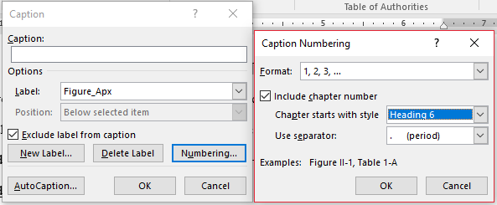
Figure A.1 Creating appendix table and figure labels

Figure A.2 Here is another figure in the appendix

The following pages show how to properly format a figure that happens to be made of many sections and is too big to fit on a single page. Please refer to figure A.3 (a) through A.3 (d) for formatting such figures, and use a similar “continued” label for tables that must be split between pages.

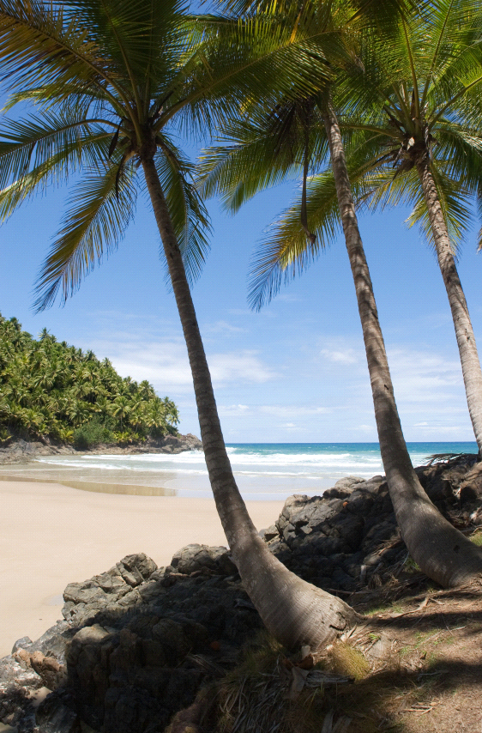
(a) (b)
Figure A.3 Examples of a pumpkin (a), palm tree (b), kid (c), and rollercoaster (d)
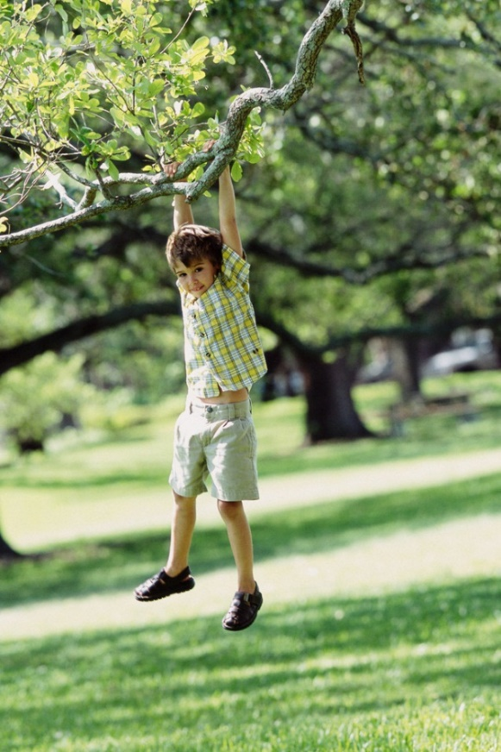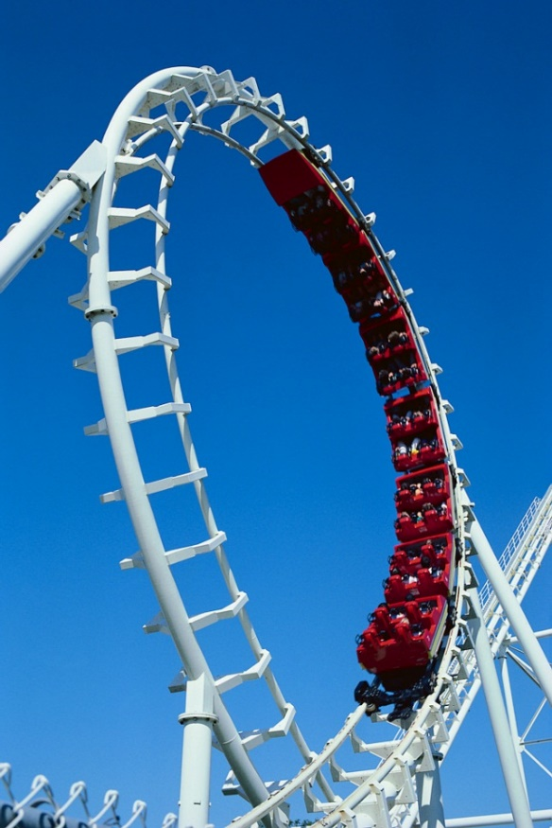
(c) (d)
Figure A.3 (cont.) Examples of a pumpkin (a), palm tree (b), kid (c), and rollercoaster (d)

Creating List of Tables and List of Figures
The lists of tables and figures are at the beginning of the report. Since appendix tables and figures were created with a different label, you will need to create two lists and put them together. To create the lists, select References and Insert Table of Figures. From there you can choose the label to use in the list (see fig. A.4).
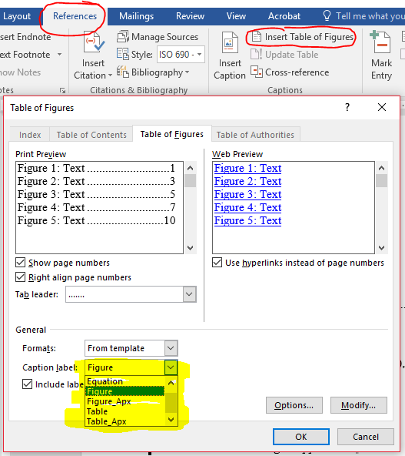
Figure A.4 Creating a table of figures

